Planting salad crops

What you will need
- Containers – any old buckets, wellies, bowls will work well!
- Good soil
- garden tools
- compost or manure
- watering can
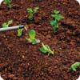
- seeds of salad crops, such as lettuce, spring onion, rocket, nasturtium, pot marigold.

Step-by-step guide
1 Help your children to dig over the soil and mix in some compost or manure.
2 They will need to plant the seeds following the guidance on the seed packets. Just ensure the children leave enough space to be able to get to the plants for watering, weeding, slug removing and picking!
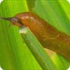
3 When they have planted the seeds, they need to water them gently. Ask your children to water them every evening if it's at all dry - seeds must be kept moist to germinate.
4 Remind your children to keep pulling out the weeds, but not to disturb the lovely salad crops.
5 Now they must wait until the salad crops look ready to eat - they'll have to be patient!
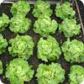
6 The nasturtiums and pot marigolds are there for two reasons: they encourage predators (pest-eaters) to come into your garden, and you can eat them too! The marigold petals and the leaves and flowers of the nasturtium will brighten up any salad.

