Nuffield STEM Futures is an innovative cross-curricular programme designed to engage young people with a vision of a sustainable and equitable future. Pupils are challenged to rethink a future based on the principles of closed loop systems in nature.
The programme is a celebration of human ingenuity rather than a review of ecological collapse.

WHY CROSS-CURRICULAR STEM?

STEM projects are based on a skills led approach, encouraging group work, reflective learning and application of STEM.

Benefits to pupils of STEM cross-curricular projects include:
- greater motivation;
- making links between subjects, enhancing learning;
- development of learning skills;
- the opportunity to tackle authentic, complex problems over an extended period of time.

STEM projects challenge pupils to development their own ideas. To help them with this, pupils are explicitly taught a set of skills. These skills build on the knowledge, skills and understanding learned through individual STEM subjects.

Skills help 11-14 pupils to:
- Develop a range of skills
- Plan and organise learning
- Formulate questions or design briefs
- Discuss and plan collaborative work
- Critique information researched from a variety of sources
- Analyse and represent data
- Develop frameworks for thinking
- Present and explain their designs or solutions
- Record and evaluate their learning journey

CASE STUDY OF NUFFIELD STEM FUTURES – SKINNERS SCHOOL

Pupils at Skinners School were challenged to rethink a positive sustainable future based on the principles of closed loop systems in nature. They explored topics through skills-based Science, Maths, and D&T activities culminating in an open, enquiry based project.

Films, resources and guidance available from:
http://www.nuffieldfoundation.org/stem/nuffield-stem-futures

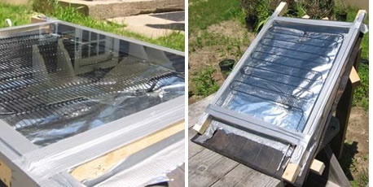
THEIR WORK AND FINDINGS

Closed Loop Tip 1: UPCYCLING

“making waste into something of higher environmental value”
Making Solar Thermal Panels from old fridge parts

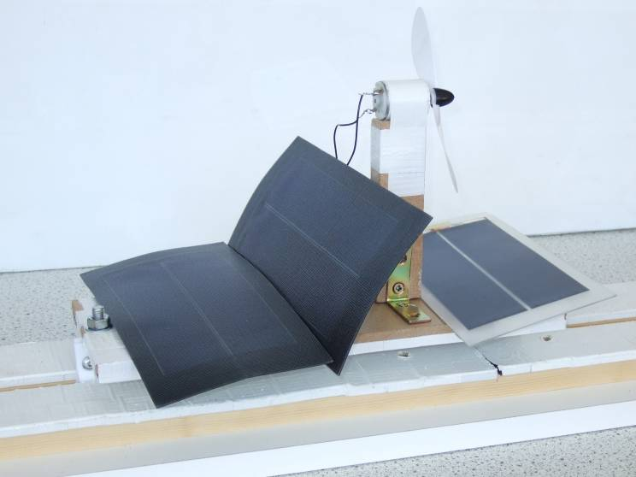

Tip 2: FUTURE THINKING
Creative ‘Green Hat’ thinking – a floating, solar-powered train

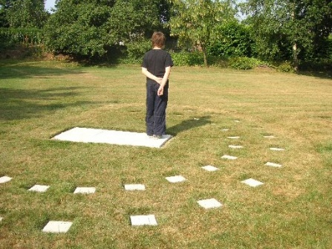
Tip 3: GET CREATIVE WITH ‘OLD’ TECHNOLOGY TOO!
Y11 pupils poured concrete into moulds for the sun-clock. Human Sun Clock - built for £25

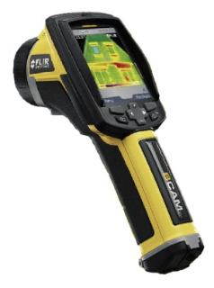

Tip 4: BORROW FROM YOUR FRIENDS!
We borrowed a FLIR Thermal Camera from our LA

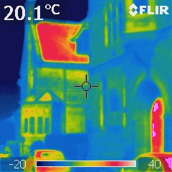
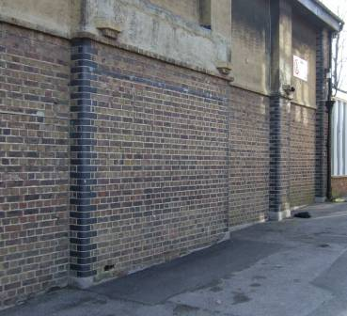
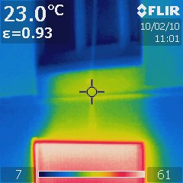

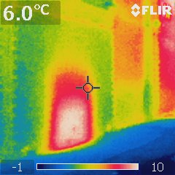

…and saw our roof needed insulating
…our windows draught-proofing
…and we found odd heat spots
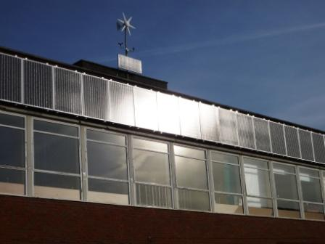

Tip 5: BE CREATIVE WITH FUNDING
Our 62 photovoltaic panels were 100% funded.

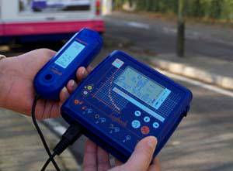

A different STEM grant allowed us to buy GPS data-loggers.

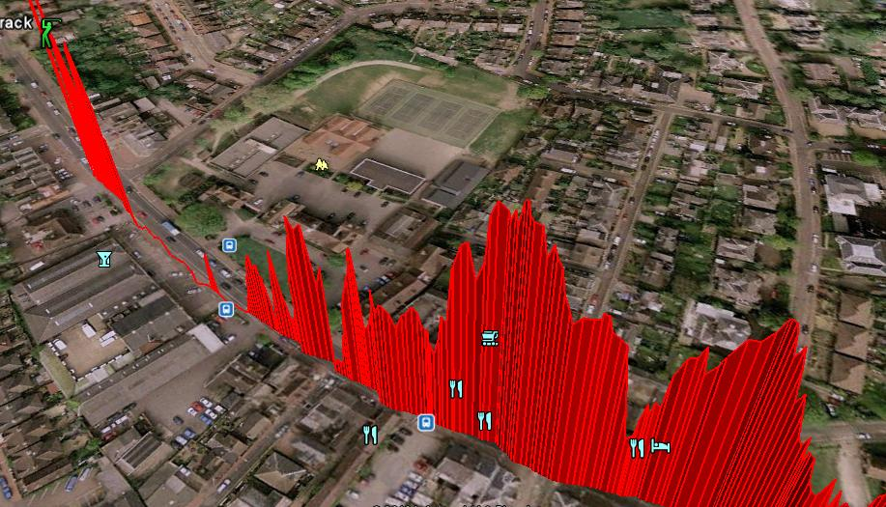
GPS data-log of SO₂ outside our school.
We used this in our Dragons' Den presentations.
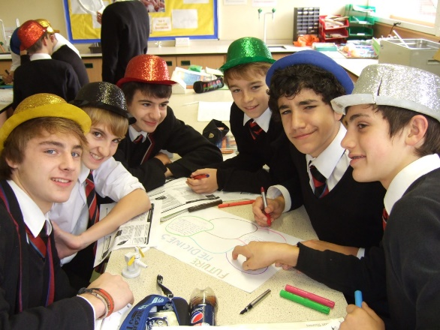

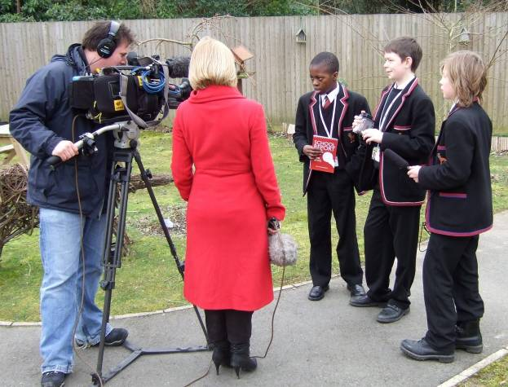

Tip 6: USE THE MEDIA TO YOUR ADVANTAGE

Tip 7: USE YOUR LOCAL HE CONTACTS
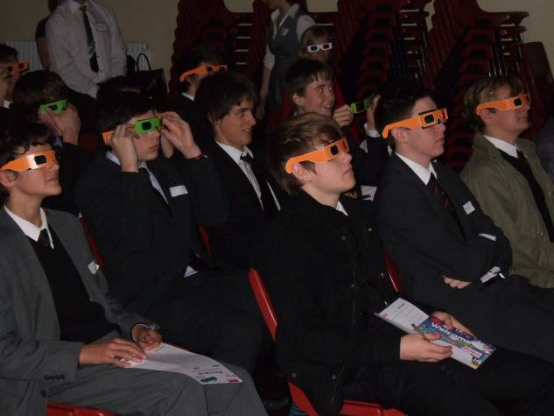

Have fun!
Practical details of the Skinners Project can be found at http://www.nuffieldfoundation.org/stem/nuffield-stem-futures

